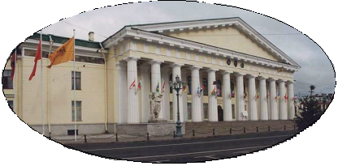
Ministry of Education and Science

Federal State Budgetary Educational Institution

of Higher Professional Education

St. Petersburg State Mining University

APPLICATION FORM

for participation in the International Forum of Students and Young Researchers

‘Topical Issues of Rational Use of Natural Resources’

April 25 – 27, 2012

(Please, fill out electronically for each applicant separately and return to
kir.fedorov@gmail.com not later than March 01, 2012)

1. | Country
2. | Surname
3. | First name
4. | Second name (patronymics)
5. | Academic degree (if applicable)
6. | University affiliation
7. | Address of the university
8. | Position at the university
9. | Title of the presentation (if applicable)
10. | Co-authors (if applicable)
11. | Working group of the conference (if applicable)
12 | Contact phone number
13 | Fax number
14. | E-mail address
Information for visa support:

Sex
Date of Birth
Place of Birth
Citizenship
Passport Number
Date of Issue
Validity of the passport
Address and fax number to send the official invitation to

IMPORTANT:
PLEASE ATTACH A SCANNED IMAGE OF YOUR PASSPORT PAGES WITH YOUR PICTURE AND ALL THE ABOVE INFORMATION.
IF YOU ARE NOT A CITIZEN OF THE COUNTRY WHERE YOU ARE STUDYING PLEASE ALSO ATTACH A SCANNED COPY OF YOUR RESIDENCE PERMIT, MULTIPLE ENTRY VISA OR ANY OTHER VALID DOCUMENT PROVING THAT YOU WILL BE ALLOWED BACK TO THE COUNTRY OF YOUR RESIDENCE.

